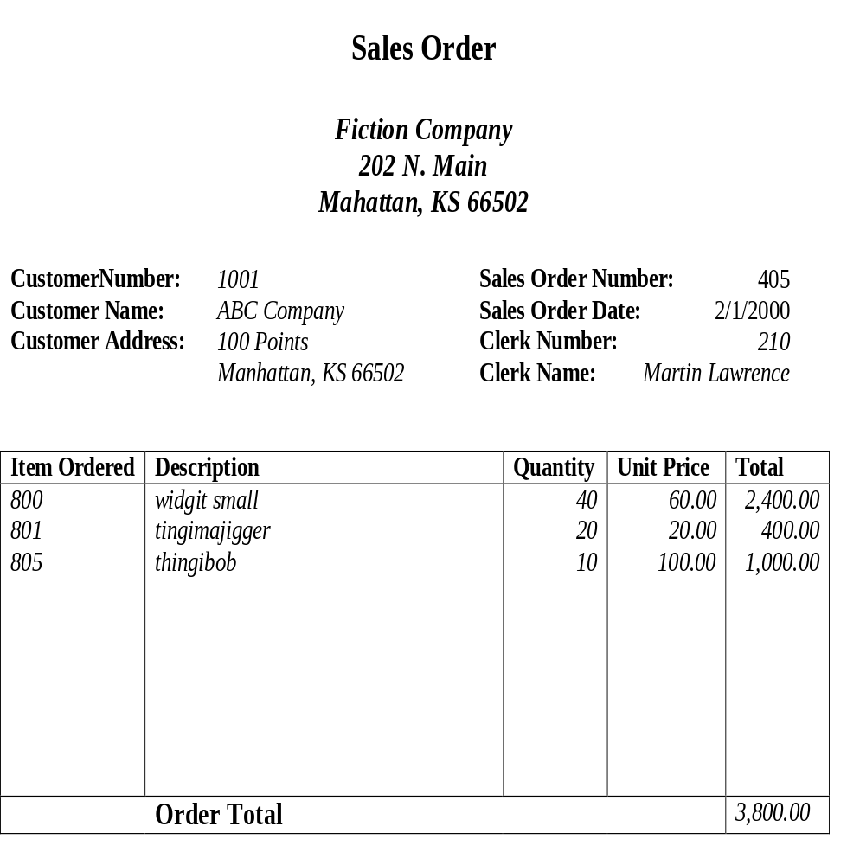
Example1:

Primary Key: Sales Order Number,
THE ANSWER OF EXAMPLE 1
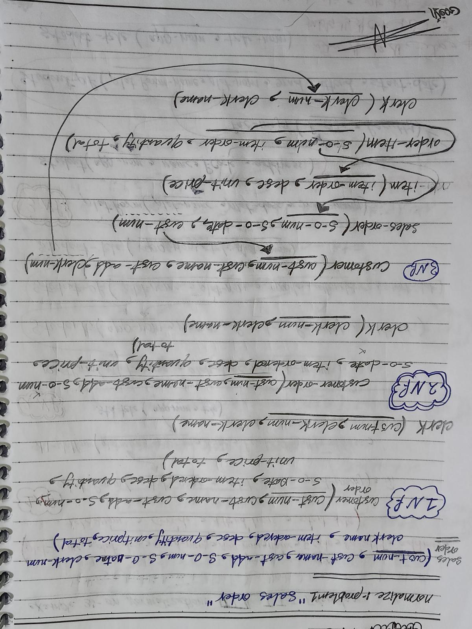

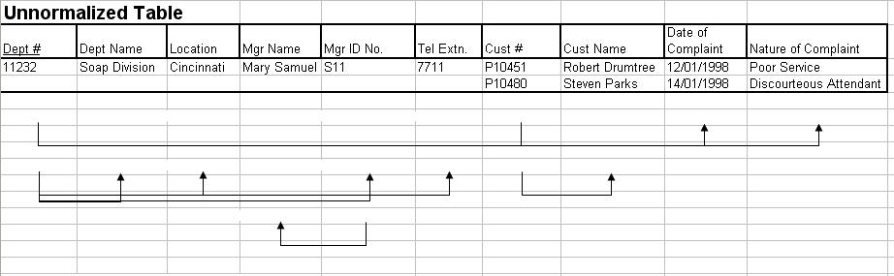
EXAPLE 2
THE ANSWER OF EXAMPLE 2
